# Lab 5 : Inter LAN Routing

## Topology Diagram

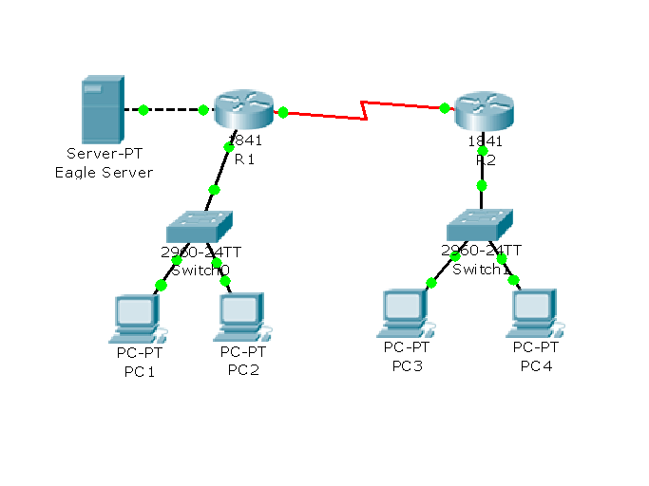

## Addressing Table

|  |  |  |  |  |
| --- | --- | --- | --- | --- |
| **Device** | **Interface** | **IP Address** | **Subnet Mask** | **Default Gateway** |
| **R1** | S0/1/0 | 10.10.10.1 | 255.255.255.252 | N/A |
| Fa0/0 | 192.168.1.1 | 255.255.255.0 | N/A |
| Fa0/1 | 192.168.2.1 | 255.255.255.0 | N/A |
| **R2** | S0/1/0 | 10.10.10.2 | 255.255.255.252 | N/A |
| Fa0/0 | 192.168.3.1 | 255.255.255.0 | N/A |
| **Eagle Server** | Fa0/0 | 192.168.2.2 | 255.255.255.0 | 192.168.2.1 |
| **PC1** | Fa0/0 | 192.168.1.2 | 255.255.255.0 | 192.168.1.1 |
| **PC2** | Fa0/0 | 192.168.1.3 | 255.255.255.0 | 192.168.1.1 |
| **PC3** | Fa0/0 | 192.168.3.2 | 255.255.255.0 | 192.168.3.1 |
| **PC4** | Fa0/0 | 192.168.3.3 | 255.255.255.0 | 192.168.3.1 |

1] Build the network topology using Packet Tracer and assign the correct display names to your networked devices. Use 1841 routers for R1 and R2. Do not connect R1 to R2 just yet.

2] Assign the ip addresses and default gateway ip addresses to PC1 to PC4 and to the Eagle server. Ensure PC1 and PC2 can ping each other and PC3 and PC4 can also ping each other.

3] The WAN link between the two routers requires Serial ports – select the R1 router and then the Physical tab. Click the WIC-2T and drag and drop this module onto the router backplane – this adds two serial ports S0/1/0 and S0/1/1 to the router. Repeat for R2.

4] To connect R1 to R2 select the WAN connection symbol with the small clock – start your connection at R1 and select port S0/1/0 and connect to R2 on port S0/1/0.

It is possible to set the ip addresses of the routers from the Config tab but we are going to do it from the CLI (command line interface) – this is essentially how routers are programmed.

5] Select the CLI on R1 and press return.

Type ? (followed by return) to see the list of available commands.

You are now in *EXEC* (executive) mode.

The prompt is now **Router>**

To program the interfaces we need to first enter *PRIVILEGE* mode.

Type **enable** (followed by return)

The prompt changes to Router#

Type ? (followed by return) to see the list of available commands.

To set the ip addresses we need to now go into ***Configuration*** mode.

Type **configure terminal (**followed by return)

The prompt changes to Router(config)#

To change the name of the router type

Router(config)#**hostname R1**

To set the ip addresses type the following

R1(config)# **interface fa0/0** (puts you into ***Interface*** mode)

R1(config-if)#**ip address 192.168.1.1 255.255.255.0**

R1(config-if)#**no shutdown** (starts the interface)

R1(config-if)#**interface fa0/1**

R1(config-if)#**ip address 192.168.2.1 255.255.255.0**

R1(config-if)#**no shutdown** (starts the interface)

R1(config-if)#**interface s0/1/0**

R1(config-if)#**ip address 10.10.10.1 255.255.255.252**

R1(config-if)#**clock rate 64000** (serial interface link need a clock signal on one end of link)

R1(config-if)#**no shutdown** (starts the interface)

Repeat the exact same process for R2 except use the correct ip addresses.

Check to see if PC1 and PC2 can ping R1 and the Eagle server.

Check to see if PC3 and PC4 can ping R2 – it should fail to ping the Eagle server.

Check to see if PC1 and ping PC3 or PC4 – it should fail.

The reason that the pings fail is the R1 and R2 are only aware of the networks directly attached to their interfaces. To see the present routing table go back to the privileged mode by typing

R1(config-if)#**exit**

R1(config)#**exit**

R1#**show ip route** (examine the routing tables on both R1 and R2 and write them down)

We will add STATIC entries into the routing tables to allow all PCs ping each other.

Select R1 and enter configuration mode by typing

R1#**configure terminal**

Enter a static entry as follows

R1(config)#**ip route 192.168.3.0 255.255.255.0 s0/1/0** (we are using the exit interface as the ‘next hop’ for the path – we could have typed ip route 192.168.3.0 255.255.255.0 10.10.10.2)

R1(config)#**exit**

R1#**show ip route**

Examine the routing table now

Codes: C - connected, S - static, I - IGRP, R - RIP, M - mobile, B - BGP

D - EIGRP, EX - EIGRP external, O - OSPF, IA - OSPF inter area

N1 - OSPF NSSA external type 1, N2 - OSPF NSSA external type 2

E1 - OSPF external type 1, E2 - OSPF external type 2, E - EGP

i - IS-IS, L1 - IS-IS level-1, L2 - IS-IS level-2, ia - IS-IS inter area

* - candidate default, U - per-user static route, o - ODR

P - periodic downloaded static route

Gateway of last resort is not set

10.0.0.0/30 is subnetted, 1 subnets

C 10.10.10.0 is directly connected, Serial0/1/0

C 192.168.1.0/24 is directly connected, FastEthernet0/0

C 192.168.2.0/24 is directly connected, FastEthernet0/1

S 192.168.3.0/24 is directly connected, Serial0/1/0

C stand for a directly connected network and S for the static entry that we entered.

Repeat the process for R2 but this time add two static entries – for 192.168.1.0 and 192.168.2.0

All machines should now be able to ping the server and each other.